**TRANSIT GATEWAY**

Account -A

==========

1. Create transit gateway

2. Create transit gateway VPC attachment

- select one subnet from each AZ

3. Verify VPC attachment to come up available and verify route tables

4. Share transit gateway to other account

Account - B

============

1. Accept the transit gateway resource

2. It will be available under transitgateway session

3. Create transit gateway VPC attachment

- select one subnet from each AZ

4. Once its came to online. we can see routetable assocication in account-A

===========

Edit private/public route tables in both accounts-A and B.

Add route to flow traffic via transit gateway

**1. Create transit gateway**

* To create a transit gateway
* choose the Region where you created the VPCs.
* On the navigation pane, choose Transit Gateways.
* Choose Create transit gateway.
* For Name tag, enter a name for the transit gateway
* For Amazon side Autonomous System Number (ASN), enter the private ASN for your transit gateway. This should be the ASN for the AWS side of a Border Gateway Protocol (BGP) session.

The range is from 64512 to 65534 for 16-bit ASNs.

The range is from 4200000000 to 4294967294 for 32-bit ASNs.

If you have a multi-Region deployment, we recommend that you use a unique ASN for each of your transit gateways.

* (Optional) You can modify the default settings if you need to disable DNS support, or if you don't want the default association route table or default propagation route table.
* Choose Create transit gateway. When the gateway is created, the initial state of the transit gateway is pending

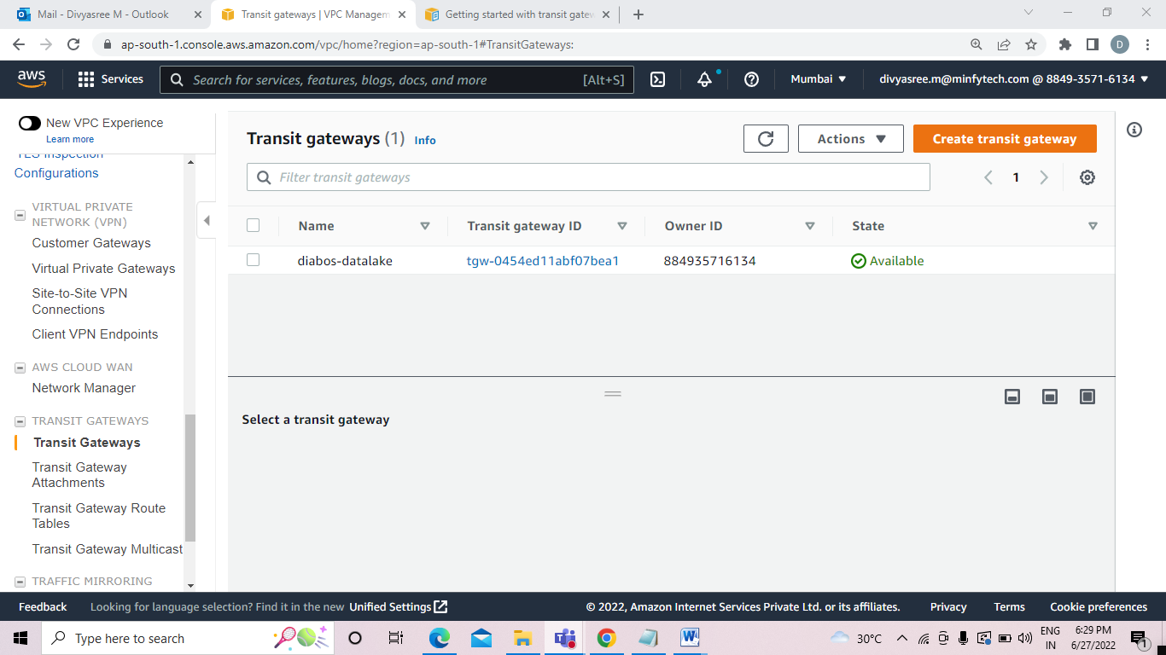

**2. Create transit gateway VPC attachment**

* On the navigation pane, choose Transit Gateway Attachments.
* Choose Create transit gateway attachment.
* (Optional) For Name tag, enter a name for the attachment
* For Transit gateway ID, choose the transit gateway to use for the attachment.
* For Attachment type, choose VPC.
* Choose whether to enable DNS support
* For VPC ID, choose the VPC to attach to the transit gateway.
* For Subnet IDs, select one subnet for each Availability Zone to be used by the transit gateway to route traffic. You must select at least one subnet. You can select only one subnet per Availability Zone.
* Choose Create transit gateway attachment.

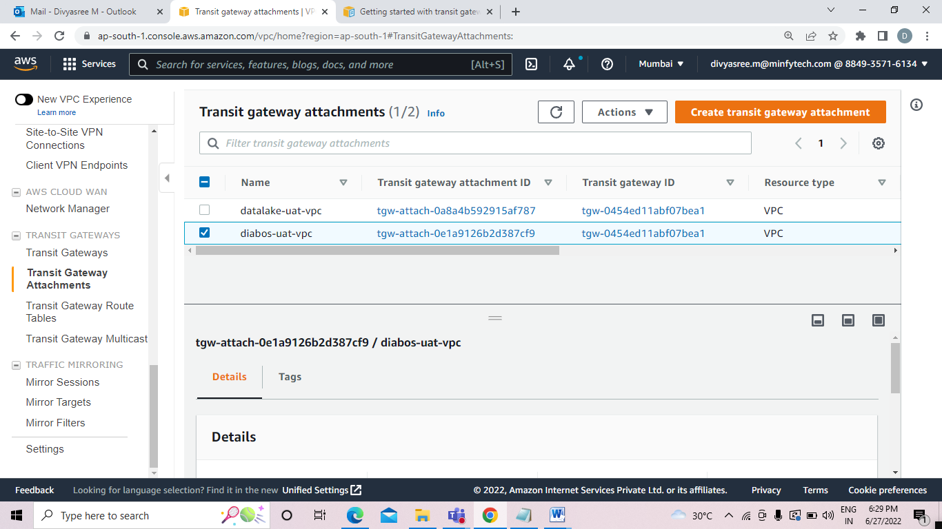

**3. Verify VPC attachment to come up available and verify route tables**

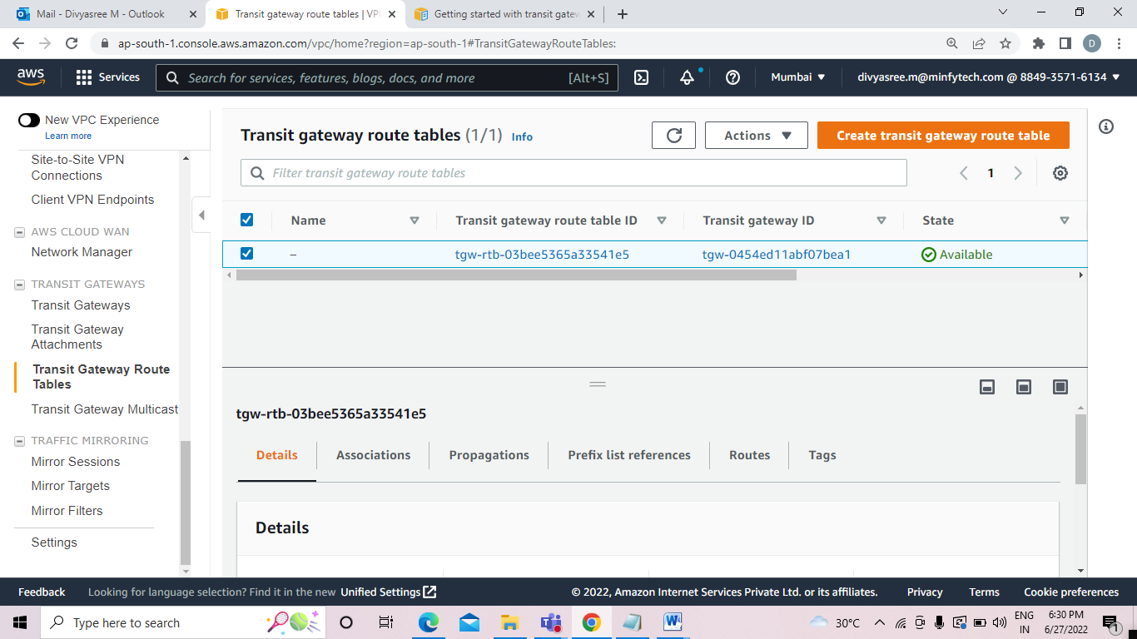

**4. Share transit gateway to other account**

To share a transit gateway

* Open the AWS RAM console at https://console.aws.amazon.com/ram/.
* Choose Create a resource share.
* Under Name, type a descriptive name for the resource share.
* For Select resource type, choose Transit Gateways. Select the transit gateway.
* For Allow external accounts, choose whether to allow sharing for this resource with AWS accounts that are external to your organization.
* (Optional) Under Tags, type a tag key and tag value pair for each tag. These tags are applied to the resource share but not to the transit gateway.
* Choose Create resource share.

**5. To accept a resource share**

* Open the AWS RAM console at https://console.aws.amazon.com/ram/.
* On the navigation pane, choose Shared with me, Resource shares.
* Select the resource share.
* Choose Accept resource share.
* To view the shared transit gateway, open the Transit Gateways page in the Amazon VPC console.

It will be available under transitgateway session

**6. To accept a shared attachment**

* Open the Amazon VPC console at https://console.aws.amazon.com/vpc/.
* On the navigation pane, choose Transit Gateway Attachments.
* Select the transit gateway attachment that's pending acceptance.
* Choose Actions, Accept transit gateway attachment
* Once its came to online. we can see route table association in diabos
* Edit private/public route tables in both accounts-A and B.
* Add route to flow traffic via transit gateway